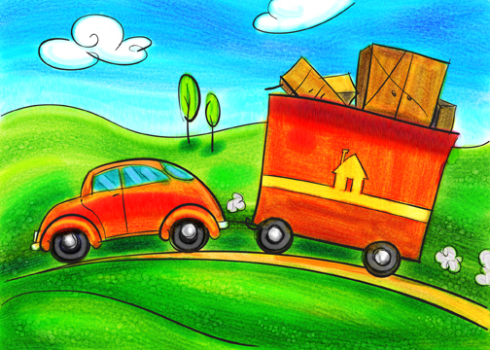

Karen Redmon

“It’s not what the world holds for you; it’s what you bring to it.”

-L.M. Montgomery